Final Technical Report Form

  - Innovation Studies for Inno4scale Project

INSTRUCTIONS
- The Progress and Final Reports (Technical and Financial) are mandatory.
- All reports are submitted by the Coordinator on behalf of all the organisations participating in the Innovation Study.
- The reports should provide a detailed picture of the project and its progress during the reporting period as described in the original application.
- The reports should be written in English.
- The Progress Technical Report should have one-page of length.
- The limit for Final Technical Report is 10 pages.
- All reports must be submitted by using the Applicant/User Account through which the project proposal was originally submitted in the PRACE Peer Review Platform.
- Please fill in the corresponding forms (Technical and Financial Forms) and submit them to the PRACE Peer Review Platform, available at https://pracecalls.eu/. All reports must be uploaded as PDFs.
- The reports cannot be used as a means to signal changes in the original objectives of the Innovation Study. These are subject to formal requests that should be submitted separately and agreed with the Inno4scale Coordinator, BSC CNS.

General Information

Innovation Study ID
Please enter your text here.

Innovation Study Title and Acronym
Please enter your text here.

Initial Project Objectives and their Final Accomplishment
Please describe briefly the main objectives of your Innovation Study, according to your proposal and/or any changes implemented, and the accomplishment level achieved for each objective.
Please enter your text here.

Final Results of the Project
Please describe briefly the overall work performed and the main results achieved during the complete implementation period. Please report clearly if your Innovation Study has achieved the expected results, and also take into account, for example, KPIs, take-up in real applications, publications and any other dissemination activities.
Please enter your text here.

HPC Performance and Benchmarking Tests Results
Please present and describe the HPC performance results for the benchmarking tests of your Innovation Study. Please report on the following performance data:
- Strong and weak scalability. Please provide the necessary plots and tables (see examples below), and information about the employed system configuration (core per node, memory, bandwith, etc.). Regarding the weak scalability, please include the problem size and the size of the smallest case.
- Precision. Please provide one of: single precision, double precision, mixed precision. Only the precision you used in your Study is relevant.
- Time-to-solution. Please provide the normalised time-to-solution average per iteration and the normalised total time to solution.
- System scale. Please provide one of: results measured on full-scale system, projected from results of smaller system, or other (please specify).
- Measurement mechanism. Please provide one of: timers, FLOP count, static analysis tool, performance modelling, other (please specify).
- Memory usage. Please specify requirements per node or core depending on the size of the problem.
- Other possible performance metrics that are code specific for the used machine (FLOPS, etc.).
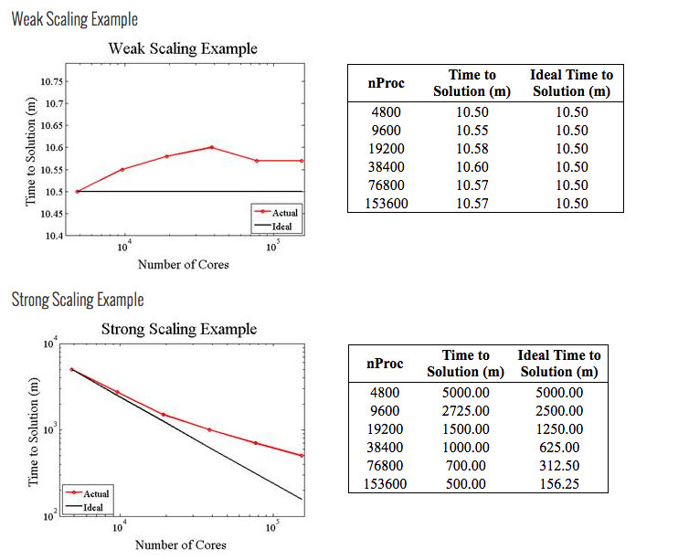
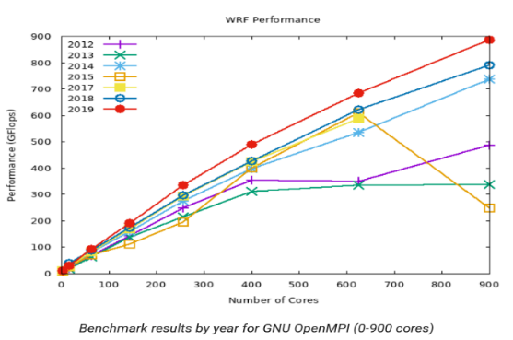
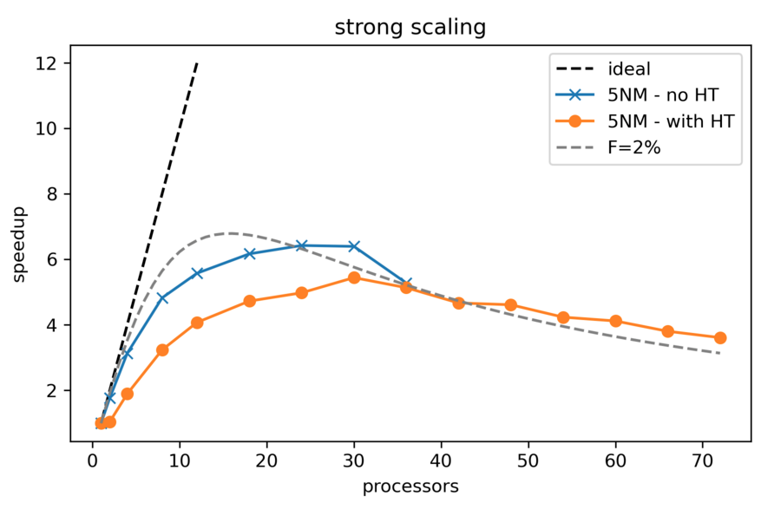
Please enter your text here.

Project Impacts on the European Exascale Supercomputers
Please describe the key impacts and value-added of your Innovation Study to the European Exascale Supercomputers.
Please enter your text here.

Enhancing and Limiting Factors on the Project Progress, Results, and Achievements
Please describe the key factors that enhanced and constrained the progress, results and outcomes of your Innovation Study.
Please enter your text here.

Lessons Learned and Suggestions
Taking into account your experience with the Inno4scale project and funding, what are your lessons learned?
Please share with us the suggestions you might have to the Inno4scale team and EuroHPC JU, in order to improve future funding actions.
Please enter your text here.

